

**AICT LAB**

HITEC UNIVERSITY TAXILA, CANTT

BSCyS-1 Semester

Fall 2024

LAB Project #1

Submitted to:

MS Amna Shakeel

Submitted by:

Talal Atta (24-Cys-048)

Saifal Ashiq (24-Cys-064)

Ameer Khan (24-Cys-062)

BS CYBER SECURITY PROGRAM DEPARTMENT OF COMPUTER SCIENCE

HITEC UNIVERSITY, TAXILA

# **Title Page:**

**WhatsApp Clone**

# **Table of Contents**

**Title Page:** 2

**Table of Contents** 3

**Executive Summary** 4

**Introduction** 4

• **Project Background** 4

• **Objective** 4

• **Scope** 4

**System Requirements** 5

• **Hardware Requirements** 5

• **Software Requirements** 5

➢ Front end 5

➢ Back end 5

➢ Development 5

**System Design** 5

• **Flowchart** 5

**Implementation** 6

• Technologies Used 6

• Code Structure 6

**Result and Discussion** 10

• Screenshots 10

• Challenges 11

**Appendices** 11

• Source Code 12

# **Executive Summary**

This report documents the development of a WhatsApp clone, a real-time messaging application. The project aimed to replicate core functionalities of WhatsApp, including user registration, login, chat messaging, and media sharing. The application was developed using a combination of HTML, CSS. The report covers the project's background, objectives, system requirements, design, implementation, results, and challenges faced during development

# **Introduction**

## **Project Background**

Messaging applications are now an indispensable part of today's communication process. With over a billion user base and various features, WhatsApp has become the yardstick for the messaging applications. This project focused on creating a simplified version of WhatsApp to learn more about the technology involved in making such applications.

## **Objective**

The goal of this project was to build a fully working messaging application that would enable the user to:

Register and log into the application.

Make groups in the chat and send messages to other users.

Share images and videos in chats.

## **Scope**

The scope of this project includes:

Front-end development using HTML, CSS, and JavaScript.

1. Real-Time Database, storing media in cloud storage.

2. Core messaging functionalities like sending/receiving text messages, images, and videos.

3. User authentication and session management

# **System Requirements**

## **Hardware Requirements**

**Minimum**: A computer with an internet connection, 2GB RAM, 1 GHz processor and storage

**Recommended:** A computer with a high-speed internet connection,8-16GB RAM,2-4GHz processor.

## **Software Requirements**

## Front end

HTML, CSS

## Back end

Need programming language.

## Development

Visual Studio

# **System Design**

## **Flowchart**

Open WhatsApp

App (Home)

Display Contacts/Chat List

(Recent Chats)

Select a Contact/Chat

Show Chat Window

(Messages, Text/Media)

Send Message (Text/Media)

Receive Messages (Text/Media)

Update Chat (New Message)

Show Updated Chat Screen

# **Implementation**

## Technologies Used

HTML and CSS

## Code Structure

**Index.html**

<div class="container">

        <div class="sidebar">

            <div class="header">

                <img src="image1.jpeg" alt="Profile" class="profile-img">

                <h1>WhatsApp</h1>

            </div>

            <div class="chat-list">

                <div class="contact">

                    <img src="image.jpeg" alt="User" class="contact-img">

                    <div class="contact-info">

                        <h2>Talal Atta</h2>

                        <p>Hello!</p>

                    </div>

                </div>

                <div class="contact">

                    <img src="image.jpeg" alt="User" class="contact-img">

                    <div class="contact-info">

                        <h3>Ameer Khan</h3>

                        <p>See you soon!</p>

                    </div>

                </div>

                <div class="contact">

                    <img src="image.jpeg" alt="User" class="contact-img">

                    <div class="contact-info">

                        <h4>Saifal Ashiq</h4>

                        <p>How are you</p>

                    </div>

                </div>

                <div class="contact">

                    <img src="image.jpeg" alt="User" class="contact-img">

                    <div class="contact-info">

                        <h4>Ali</h4>

                        <p>Hi</p>

                    </div>

                </div>

            </div>

        </div>

        <div class="chat-window">

            <div class="header">

                <img src="image.jpeg" alt="User" class="profile-img">

                <h3>Talal Atta</h3>

            </div>

            <div class="messages">

                <div class="message sender">

                    <p>Hello!</p>

                </div>

                <div class="message receiver">

                    <p>Hi, how are you?</p>

                </div>

                <div class="message sender">

                    <p>I'm good, thanks for asking!</p>

                </div>

            </div>

            <div class="message-input">

                <input type="text" placeholder="Type a message...">

                <button>Send</button>

            </div>

        </div>

    </div>

</body>

</html>

**Explanation**

**Container (.container):**

Contains both the sidebar and chat window sections.

**Sidebar (.sidebar):**

Includes the profile image, the app name (WhatsApp), and a list of contacts. Each contact is displayed with a profile image, name, and last message.

The contact list is made with .contact elements, each consisting of an image and the contact's information.

**Chat Window (.chat-window):**

Contains a header displaying the contact's profile image and name.

The messages section displays individual messages from the sender and receiver, each having distinct background colors as defined in your CSS (sender and receiver classes).

The message input area consists of an input field and a "Send" button.

**Style.css**

<!DOCTYPE html>

<html lang="en">

<head>

    <meta charset="UTF-8">

    <meta name="viewport" content="width=device-width, initial-scale=1.0">

    <title>WhatsApp Clone</title>

    <style>

        * {

            margin: 0;

            padding: 0;

            box-sizing: border-box;

        }

        .container {

            display: flex;

            height: 300vh;

        }

        .sidebar {

            width: 450px;

            background-color: #075E54;

            color: white;

            display: flex;

            flex-direction: column;

            padding: 20px;

        }

        .sidebar .header {

            display: flex;

            align-items: right;

            margin-bottom: 30px;

        }

        .sidebar .profile-img {

            border-radius: 100%;

            margin-right: 10px;

        }

        .sidebar h2 {

            font-size: 24px;

            font-weight: 100;

        }

        .chat-list {

            flex-grow: 5;

        }

        .contact {

            display: flex;

            align-items: center;

            margin-bottom: 15px;

            cursor: pointer;

        }

**Explaination**

**Global Styles:**

Resets default margins, padding, and box-sizing for all elements (* selector).

Container: The .container class sets up a flex box layout with a height of 100% of the viewport (100vh), allowing the sidebar and chat window to align side by side.

**Sidebar Styling:**

.sidebar is styled to have a fixed width, background color, white text, and some padding. It uses flex box to arrange elements vertically.

The profile section (.header) has a flex layout to position the profile image and name.

The .contact class is used for chat contacts, with hover effects to highlight them. It also uses flex box for alignment.

.contact-img ensures profile images are circular, and .contact-info styles the contact's name and status

**Chat Window Styling**:

The .chat-window class takes up the remaining space, with a light gray background.

.chat-window .header contains the header of the chat window, styled with a background color and padding.

The .messages class is the container for the chat messages and allows scrolling when messages overflow.

.message has padding, rounded corners, and word wrapping to ensure text fits properly.

.sender and .receiver are styled with distinct background colors to differentiate the sender’s and receiver’s messages.

**Message Input Area or Radio button**:

The .message-input container is styled to have a background color, padding, and a border between the input and message area.

The input field has a width of 90%, padding, and rounded corners. The send button is styled to fit 10% of the width, with a green background and a hover effect

Or

<input type="radio" id="chat3" name="chat" />

Each contact label is linked to a radio button via the for attribute. When a contact is clicked, it activates the corresponding radio button.

Each radio button is connected to its respective chat window by using the :checked pseudo-class to control which chat window is visible.

# **Result and Discussion**

## Screenshots

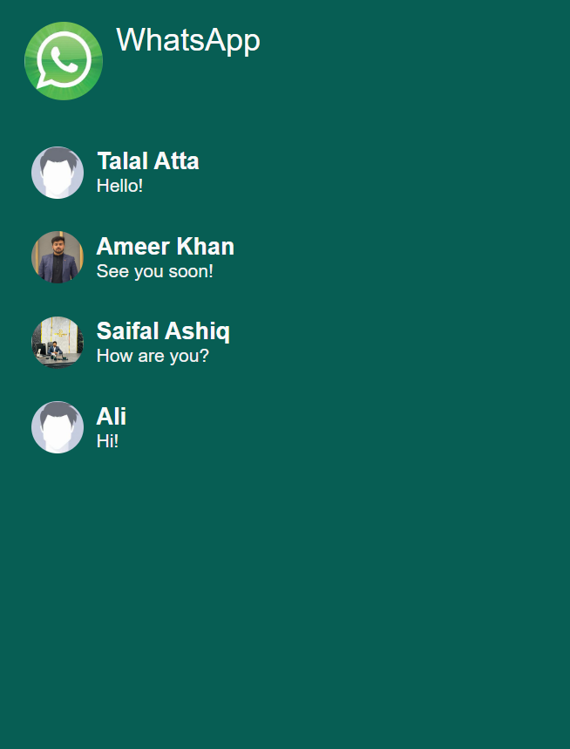

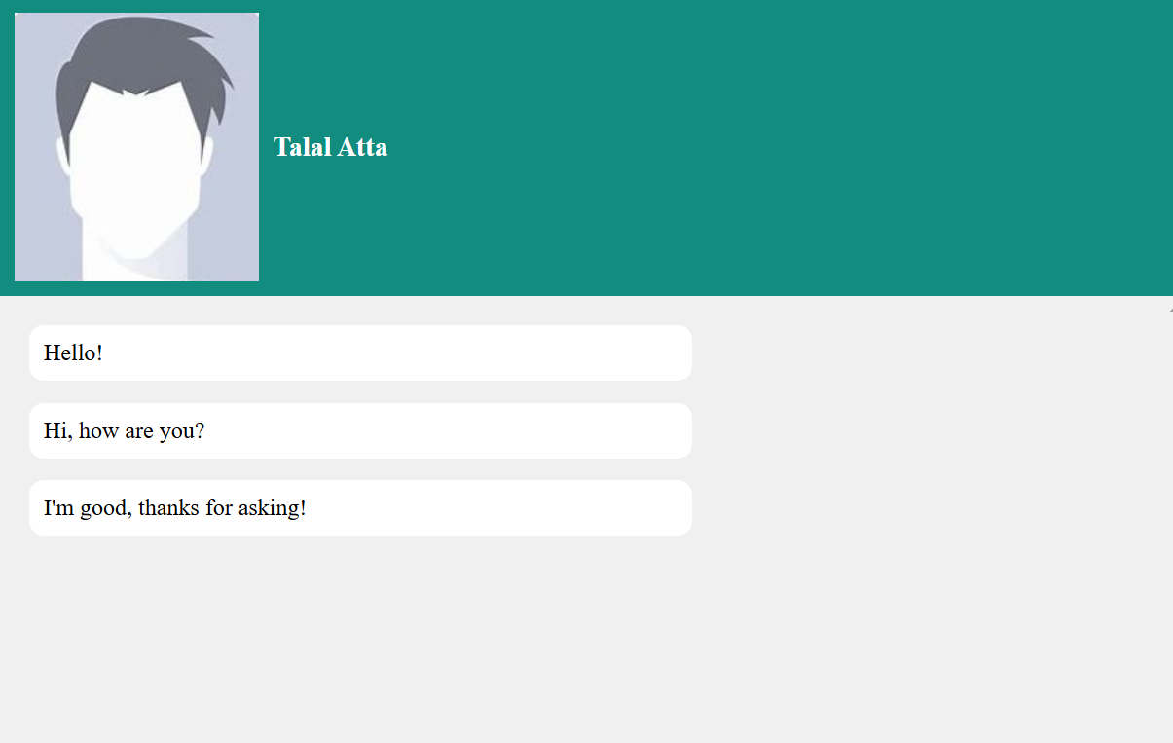



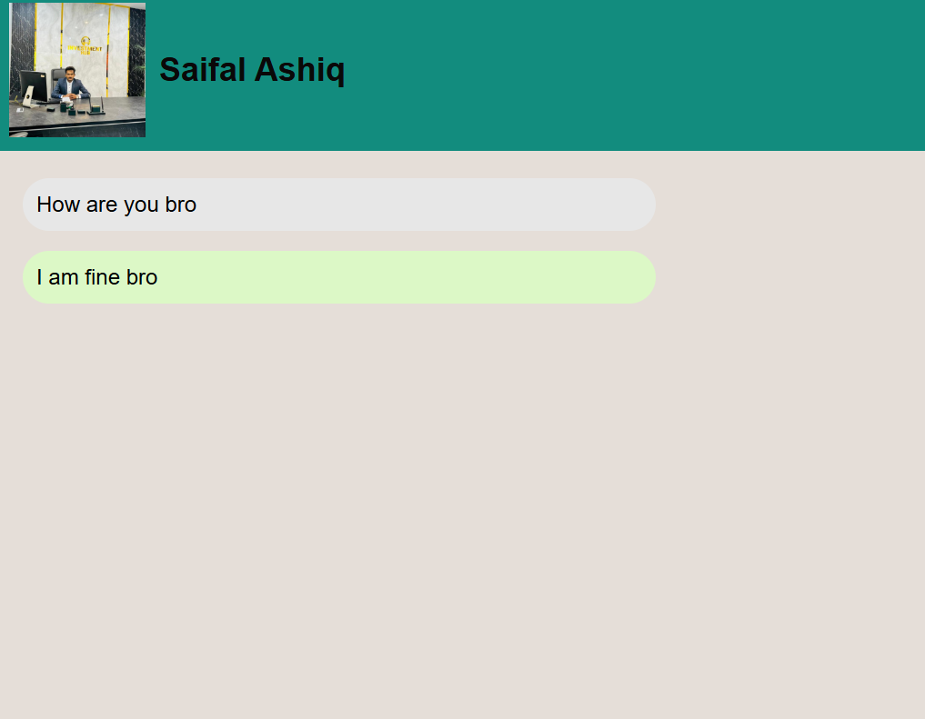



## Challenges

Real-time Messaging.

User Authentication.

Media Sharing (Images ,Videos ,files

# **Appendices**

## Source Code

**https://github.com/Talal274/AICT-Project**